Understanding Daily Behavioral Patterns of Working Students through

Exploratory Data Analysis: A Quantified Self Case Study

Brando Allen A. Donato

National University, Manila, Philippines,

[donatoba@students.national-u.edu.ph](mailto:fn5an@virginia.edu)

**Abstract.** This study examines daily behavioral patterns of a working student in Metro Manila over 89 days through structured self-tracking and their relationship to mood and focus. Data were collected via Google Sheets daily logs and analyzed using exploratory data analysis and inferential statistics. Variables included sleep, work/study hours, distraction time, travel time, tasks completed, and 5-point Likert scales for mood and focus. Three hypotheses were tested: (1) Recovery vs. Inertia—whether rest days precede deep work or sustained low performance; (2) Busywork vs. Flow State—whether high-volume days can be distinguished by focus ratings; and (3) Weekend Bleed—whether work intrudes into weekends and impacts mood. Results revealed a strong mood-focus correlation (r = 0.62, p < 0.05). Transition analysis supported inertia over recovery: zero rest days (0/8) preceded deep work, while 37.5% led to continued low performance. Among 44 high-volume days, focus significantly discriminated Busywork (M = 1.73) from Flow State (M = 3.93; t = -9.82, p < 0.001). Work/study patterns appeared on 34.8% of weekends without significant calendar association (χ² = 1.98, p = 0.16); surprisingly, weekend work days showed higher mood (M = 3.50) than weekend rest days (M = 2.80). Findings demonstrate that unstructured rest does not predict next-day productivity, focus quality distinguishes productive from merely busy days, and weekend work may not harm well-being for intrinsically motivated students. This research illustrates how quantified self-methods transform behavioral intuitions into testable hypotheses and actionable insights for working students managing dual academic-professional demands.

**Keywords:** Quantified Self · Working Students · Exploratory Data Analysis · Self-Tracking · Behavioral Patterns · Productivity Analysis · Flow State · Recovery · Inertia · Weekend Bleed

# Introduction

## 1.1 Background of the Study

In the contemporary landscape of pervasive computing, the "Quantified Self" (QS) movement has transitioned from a niche hobby to a rigorous method of self-knowledge through data, enabling individuals to treat "The Day" as a distinct, measurable data point [1]. For working students in high-density urban environments like Metro Manila, daily life represents a complex optimization problem where time is a scarce resource divided among professional output, academic deadlines, travel time, and the physiological necessity of rest. While students often rely on intuition to gauge their productivity, such perceptions are frequently flawed; a day characterized by high screen time may feel "busy" but result in low output, whereas a day of rest might be perceived as "lazy" but actually serve as a critical recovery mechanism. By aggregating consistent, self-reported daily logs using manual input, this study aims to move beyond flawed intuition toward an objective, evidence-based understanding of how daily behaviors relate to cognitive performance and well-being.

Previous research in the domain of educational data mining, such as the SmartGPA and StudentLife studies, has indicated that significant correlations exist between lifestyle factors—including sleep patterns, socialization, and study duration—and a student's academic success. These studies have shown that behavioral features like increased time at academic facilities and decreased location variation are strong indicators of higher academic performance [2]. Furthermore, personality traits such as conscientiousness have been identified as long-term indicators of higher-grade point averages [3]. This study builds upon these established frameworks by applying exploratory data analysis and inferential statistics to a single-subject dataset, specifically investigating the nuances of the working student profile in a modern "Big Data" era.

## 1.2 Problem Statement and Research Questions

Despite the wealth of data provided by modern wearables, there remains a critical ambiguity in how students distinguish between high-volume "Busywork" and true "Flow States," as raw work hours often fail to account for subjective focus and cognitive depth. This research addresses the "Recovery vs. Inertia" paradox, questioning whether periods of rest effectively prime a student for subsequent "Deep Work" or if unstructured downtime instead precipitates a continued state of low performance. Additionally, the study explores the "Weekend Bleed" effect, analyzing the extent to which professional and academic obligations intrude into weekends and how this permeability of work-life boundaries influences self-reported mood and focus. The overarching goal is to identify the patterns existing in daily inputs—such as music genre, travel time, and distraction—to determine their precise relationship with a student's ability to maintain high-focus productivity profiles.

What patterns exist in daily inputs (music genre, sleep, travel time) and behaviors (work hours, study hours, distraction time), and how do these patterns relate to self-reported mood and focus? First, Recovery vs. Inertia Hypothesis: Do "Rest Profiles" (High Leisure, Low Productivity) typically precede "Deep Work" patterns (suggesting recovery), or do they precede further low-performance patterns (suggesting inertia)? Second, Busy vs. Productive Distinction: Can data analysis distinguish between "High-Volume / Low-Focus" days (Busywork) and "High-Volume / High-Focus" days (Flow State) based on the relationship between Work Hours and Distraction Time? Lastly, Weekend Bleed Effect: Do specific habit patterns strictly align with calendar weekends, or do "Work/Study" patterns significantly intrude into weekends, and is this intrusion associated with "Low Mood" outcomes?

## 1.3 Significance of the Study

This research contributes to the growing body of literature on educational data mining and personal informatics by examining the lived experience of working students through quantitative self-tracking methods. The findings may inform evidence-based strategies for time management, work-life balance optimization, and mental health maintenance among students who juggle multiple responsibilities. By identifying actionable patterns in daily behavior and their relationship to cognitive performance, this study provides a framework for students to move from intuitive self-assessment to data-driven decision-making about their schedules and habits. Furthermore, the single-subject design allows for deep, granular analysis that complements large-scale studies by capturing the individual variation and contextual nuances often lost in aggregate data. The insights gained from this research may benefit educational institutions in understanding the unique challenges faced by working students, potentially informing support services, scheduling policies, and wellness programs tailored to this demographic.

## 1.4 Scope and Limitations

This study focuses on a single working student’s daily behavioral pattern over an extended period, tracked through self-reported logs and wearable device data. The analysis examines relationships between various lifestyle factors (sleep, work hours, study hours, leisure time, travel time, music listening habits) and self-reported outcomes (mood, focus, productivity).

The scope of this research encompasses the analysis of daily behavioral patterns and their correlates, with particular attention to the examination of weekday versus weekend patterns. The investigation delves into temporal sequences, such as whether rest days precede productive days, and explores the relationship between objective metrics derived from wearable devices and subjective assessments of well-being. This approach allows for a comprehensive understanding of how different aspects of daily life interact and influence one another over time.

However, several limitations must be acknowledged. The single-subject design, while allowing for deep granular analysis, limits the generalizability of findings to broader populations. Self-reported data may be subject to recall bias or reporting inconsistencies, as participants may not always accurately remember or record their daily activities and emotional states. Additionally, this study examines correlations rather than establishing causal relationships between variables; observed associations do not necessarily imply that one factor directly causes changes in another. Context-specific factors unique to Metro Manila's urban environment, such as extreme traffic conditions and high population density, may not apply to other settings, potentially limiting the applicability of findings to students in different geographical contexts. Finally, the specific profile of a working student who maintains concurrent employment while pursuing academic studies may differ substantially from traditional full-time students who do not face the same dual demands on their time and cognitive resources.

# Related Work

## Quantified Self and Educational Data Mining

The integration of mobile sensing technologies with educational research has enabled unprecedented insights into student behavior and academic performance. The Quantified Self movement represents a paradigm shift from intuitive self-assessment to objective, data-driven understanding of personal behavior patterns. This approach has become particularly relevant in educational contexts, where researchers have begun to leverage smartphone and wearable technology to understand the complex interplay between student behaviors and academic outcomes [1].

The SmartGPA study pioneered the use of smartphone sensor data to predict and understand college student academic performance. This groundbreaking research demonstrated that behavioral features extracted from mobile devices could serve as reliable indicators of academic success. The study concluded that students who spend time at fraternities tend to perform more poorly academically, while students who socialize more at their dorms are more likely to have higher GPAs. Furthermore, the research correlated increasing conversation duration with higher GPA, which could indicate more group work and communication towards the end of the semester. The Lasso regression analysis employed in the SmartGPA study selected conscientiousness as the primary long-term indicator of higher-grade point average, suggesting that personality traits play a crucial role in academic outcomes [1].

Building upon this foundation, the StudentLife project further demonstrated that assessing mental health, academic performance, and behavioral trends through smartphones provides valuable insights into student well-being and success. This comprehensive study tracked college students throughout an entire semester, collecting data on physical activity, social interactions, study patterns, and mental health indicators. The findings revealed complex relationships between lifestyle factors and academic achievement that would be impossible to capture through traditional survey methods alone [2].

While these studies leveraged automated sensor data collection, alternative approaches using structured self-reporting have also proven valuable in understanding student behavior patterns. Self-reported daily logs offer certain advantages, including the ability to capture subjective states such as mood and focus that are difficult to infer from sensor data alone, as well as the capacity to record context-specific activities that automated systems may misclassify. This approach allows for intentional reflection on daily activities, potentially increasing participant awareness of their own behavioral patterns.

While these studies leveraged automated sensor data collection, alternative approaches using structured self-reporting have also proven valuable in understanding student behavior patterns. Self-reported daily logs offer certain advantages, including the ability to capture subjective states such as mood and focus that are difficult to infer from sensor data alone, as well as the capacity to record context-specific activities that automated systems may misclassify. This approach allows for intentional reflection on daily activities, potentially increasing participant awareness of their own behavioral patterns.

## Lifestyle Factors and Academic Performance

Previous research has consistently indicated that correlations exist between lifestyle factors—such as study habits, study duration, socialization time, and campus involvement—and a student's academic success. These relationships extend beyond simple time allocation to encompass the quality and context of student activities, as well as their physical and mental health status.

One fundamental lifestyle factor is class attendance conducted research at the College of New Jersey that correlated higher attendance rates with higher GPA outcomes. Using a least-squares regression and a defined probability model, this study compared the number of missing classes with GPA and concluded that students who did not miss more than three classes per week were significantly more likely to achieve a GPA in the 3.1 to 4.0 range. This finding underscores the importance of consistent academic engagement as a predictor of success [3].

Mental health represents another critical dimension of student performance. Research has demonstrated that mental health significantly impacts academic success in college, with depression and anxiety showing consistent negative effects on performance, found that mental health conditions not only affect current academic performance but can also have lasting impacts on degree completion and career trajectories. The relationship between mental health and academic achievement appears to be bidirectional, with poor academic performance potentially exacerbating mental health challenges while mental health difficulties simultaneously undermine academic capabilities [4].

Personality traits constitute long-term predictors of academic outcomes that operate independently of immediate behavioral patterns. A study identified conscientiousness as strongly associated with higher college grade point averages. Conscientiousness, characterized by dutifulness, self-discipline, and achievement orientation, predicts academic success across diverse contexts and populations. This personality trait appears to influence not only the quantity of effort students invest in their studies but also the consistency and organization with which they approach academic tasks. However, considerable research gaps remain regarding how significantly personality impacts academic success in comparison to environmental and behavioral factors [5].

Physical activity represents another lifestyle factor with documented relationships to academic performance. A study found that college student work habits are related to physical activity and fitness levels, suggesting that students who maintain regular physical exercise may develop time management and self-regulation skills that transfer to academic contexts [6]. Similarly, research demonstrated that physical activity correlates with higher GPAs among health science graduate students, with moderate levels of exercise associated with optimal academic outcomes [7]. These findings suggest that physical health and academic performance are not competing priorities but rather mutually reinforcing aspects of student success.

Stress constitutes a complex factor in academic achievement. While high levels of stress generally correlate with poorer academic outcomes, the relationship is not entirely linear. Elias et al. [8] examined stress and academic achievement among undergraduate students, finding that moderate stress can sometimes serve as a motivating factor, while excessive stress becomes debilitating [8]. The key appears to lie not in eliminating stress entirely but in developing effective coping mechanisms and maintaining stress at manageable levels.

Despite extensive research on individual lifestyle factors, significant gaps remain in our understanding of how these factors interact within the context of working students. Most existing studies focus on traditional full-time students who do not face the dual demands of concurrent employment and academic responsibilities. Working students must navigate additional constraints including limited time availability, competing professional obligations, and the cognitive load of context-switching between work and study roles. Understanding how lifestyle factors influence academic performance within this specific population requires targeted research that acknowledges these unique challenges.

# Methodology

## Participant and Data Collection

This study employed a single-subject design (n = 1) focusing on a working student residing in Metro Manila. The participant is a full-time professional concurrently enrolled in a Data Science program. Data collection spanned a duration of 89 days, commencing on November 19, 2025, and concluding on February 15, 2026. A structured daily logging instrument hosted on Google Sheets served as the primary data collection tool. Entries were recorded once daily at the conclusion of the day to ensure consistency. Participation in this study was voluntary, and the data is self-reported with full informed consent utilized for academic analysis

## Variables and Operational Definitions

The study tracked a set of daily variables categorized into temporal allocation, performance output, and subjective well-being. Table 1 presents the primary variables and their operational definitions. Quantitative metrics included durations for sleep, professional work, academic study, and commuting, alongside a discrete count of completed tasks. Subjective states—specifically mood and focus—were assessed using a standard 5-point Likert scale ranging from 1 (Very Poor) to 5 (Excellent).

Beyond raw metrics, composite variables were synthesized to categorize daily performance profiles. A "Work/Study Profile" was defined as days where combined work and study hours exceeded the median. These high-volume days were further classified into "Flow State" (high focus) or "Busywork" (low focus) based on the median split of the Focus_Rating variable. Additionally, a "Weekend Bleed" indicator was derived to track the intrusion of high-workload profiles into Saturday and Sunday.

**Table 1.** List of variables used in analysis.

|  |  |
| --- | --- |
| **Feature Category** | **Feature** |
| Sleep Hours | Duration of sleep previous night (hours) |
| Work Hours | Estimated professional work (hours) |
| Study Hours | Estimated academic study (hours) |
| Distraction Time Minutes | Time on social media, games, entertainment (minutes) |
| Travel Time Hours | Commute duration (hours) |
| Tasks Completed | Number of tasks accomplished (count) |
| Mood Rating | Self-reported mood 1-5 (very poor to excellent) |
| Focus Rating | Self-reported focus 1-5 (very poor to excellent) |
| Is Weekend | Saturday/Sunday (derived from date) |

## Data Preprocessing

The raw dataset underwent preprocessing using Python (Pandas library). Missing numeric values, which indicated a lack of activity (0 work hours on a rest day), were imputed with zero to preserve the integrity of mathematical operations. Categorical variables, such as "Mode of Transport" and "Music Genre," were transformed using one-hot encoding. Outliers identified through visual inspection (box plots) were retained, as they represented genuine behavioral variations—such as "crunch time" workdays—rather than measurement errors. Finally, continuous variables were standardized using Z-score normalization.

$$z=\frac{\left(x-µ\right)}{σ}$$

## Statistical Analysis Methods

### Derived Variables and Operational Definitions

To support hypothesis testing, composite variables were synthesized to categorize daily performance profiles based on median splits of the dataset. The following operational definitions were applied:

Rest Day: A day characterized by both Work_Hours < median AND Study_Hours < median AND Distraction_Time_Mins > median. This profile represents days with minimal productive activity and high leisure engagement.

Deep Work Day: A day where (Work_Hours + Study_Hours) > median AND Distraction_Time_Mins < median. This profile captures high productivity with minimal interruption.

High-Volume Day: Any day where (Work_Hours + Study_Hours) > median, regardless of distraction level.

Flow State: Among high-volume days, those with Focus_Rating > median (indicating high subjective engagement).

Busywork: Among high-volume days, those with Focus_Rating ≤ median (indicating low subjective engagement despite high time investment).

Work/Study Profile: Days where (Work_Hours + Study_Hours) > median, used to identify productive days.

Weekend Bleed: The occurrence of a Work/Study Profile on Saturday or Sunday, indicating intrusion of work patterns into weekends.

### Descriptive and Exploratory Analysis

The analysis commenced with the calculation of measures of central tendency (mean, median) and dispersion (standard deviation, range) for all continuous variables. Time-series visualizations were generated to identify longitudinal trends and temporal patterns across the 89-day observation period. Distribution characteristics were assessed through histograms and box plots to detect skewness, bimodality, and outliers.

Pearson correlation matrices were generated to assess linear relationships between continuous variables (Sleep_Hours, Work_Hours, Study_Hours, Travel_Time_Hours, Distraction_Time_Mins, Tasks_Completed, Mood_Rating, Focus_Rating). Correlation coefficients (r) were tested for statistical significance at α = 0.05 to identify meaningful pairwise associations that inform subsequent hypothesis testing.

### Comparative Analysis: Weekday vs. Weekend

Independent-samples t-tests were conducted to compare means between weekday and weekend contexts for key variables including Work_Hours, Study_Hours, Mood_Rating, and Focus_Rating. A t-test was specifically employed due to its robustness to unequal sample sizes (58 weekdays vs. 23 weekend days) and potential heterogeneity of variance between groups. The test statistic (t), degrees of freedom (df), and p-value were reported for each comparison, with statistical significance determined at α = 0.05.

The null hypothesis for each test posited no difference in mean values between weekdays and weekends. Rejection of the null hypothesis would indicate that temporal context (weekday vs. weekend) significantly influences the measured variable.

### Hypothesis Testing

Three primary hypotheses were tested using inferential statistical methods:

#### Hypothesis 1: Recovery vs. Inertia

To evaluate whether Rest Days facilitate subsequent productivity (Recovery Hypothesis) or perpetuate low performance (Inertia Hypothesis), a transition analysis was performed. For each of the identified Rest Days (n = 8), the profile of the immediately following day was classified as:

Rest → Deep Work (supporting Recovery)

Rest → Low Performance (supporting Inertia)

Rest → Other (moderate activity)

The conditional probability P(Deep Work Day | Previous Day = Rest Day) was calculated as the proportion of Rest Days followed by Deep Work Days. Similarly, P(Low Performance | Previous Day = Rest Day) was computed. These proportions were compared to assess which hypothesis received empirical support.

#### Hypothesis 2: Busywork vs. Flow State

To distinguish between high-volume work with low cognitive engagement (Busywork) versus high-volume work with high engagement (Flow State), all High-Volume Days were classified based on median Focus_Rating. An independent-samples t-test compared mean Focus_Rating between Busywork days and Flow State days to validate this classification. Statistical significance at α = 0.05 would confirm that Focus_Rating robustly discriminates between these qualitatively different productivity modes.

#### Hypothesis 3: Weekend Bleed Effect

To assess whether professional and academic obligations intrude into weekends in a systematic pattern, a chi-square test of independence was conducted on a 2×2 contingency table crossing Is_Weekend (Weekend vs. Weekday) with Work/Study Profile (Present vs. Absent). The null hypothesis posited independence between these variables (i.e., work patterns occur equally on weekends and weekdays). The chi-square statistic (χ²), degrees of freedom (df = 1), and p-value were computed, with significance determined at α = 0.05.

Additionally, mean Mood_Rating was compared between "Weekend Bleed" days (weekends with Work/Study Profile) and "Weekend Rest" days (weekends without Work/Study Profile) using descriptive statistics to assess whether weekend work is associated with reduced well-being.

### Software and Statistical Tools

**Table 2.** Tools and description used in the whole environment

|  |  |  |
| --- | --- | --- |
| **Tools** | **Version** | **Description** |
| Python | 3.9.25 | Python version used in the analysis |
| Pandas | 2.3.3 | Data manipulation and preprocessing |
| NumPy | 2.0.2 | Numerical computations |
| SciPy | 1.13.1 | Statistical tests |
| Seaborn | 0.13.2 | Data visualization |
| Matplotlib | 3.9.4 | Data visualization |
|  |  |  |

# Results

## Descriptive Statistics and Dataset Characteristics

The final dataset consists of 89 consecutive daily observations (N = 89) collected from November 19, 2025, to February 15, 2026, comprising 63 weekdays (70.79%) and 26 weekend days (29.21%). Table 1 summarizes the descriptive statistics for all numerical variables.

The data reveals substantial variability in sleep and productivity metrics. Sleep duration averaged 6.92 hours (SD = 1.80), but the range (2.00 – 12.00 hours) and the bimodal distribution observed in histograms suggest an inconsistent sleep schedule characterized by distinct periods of deprivation and recovery. Digital distraction was notably high, with a daily mean of 253.36 minutes (approximately 4.22 hours), and followed an approximately normal distribution.

Conversely, Work Hours (M = 4.94) exhibited a right-skewed distribution, indicating that while many days involved minimal professional work, specific intensive days reached up to 10 hours. Subjective well-being metrics (Mood and Focus) averaged near the midpoint of the 5-point scale (M = 3.40 and M = 3.28, respectively), with mood displaying a bimodal distribution that implies distinct "good" and "poor" days rather than a consistent neutral state.

**Table 3.** Descriptive Statistics of Daily Logs (N = 89)

|  |  |  |  |  |  |  |
| --- | --- | --- | --- | --- | --- | --- |
| **Variable** | **Mean** | **Median (50%)** | **Min** | **Std. Dev.** | **Max** | **Range** |
| Sleep Hours | 6.92 | 7 | 2 | 1.8 | 12 | 10 |
| Work Hours | 4.94 | 7 | 0 | 3.34 | 10 | 10 |
| Study Hours | 4.68 | 4.7 | 0 | 2.38 | 11.73 | 11.73 |
| Travel Time (Hours) | 1.7 | 1.4 | 1 | 0.73 | 3 | 2 |
| Distraction Time (Mins) | 253.36 | 240 | 70 | 85.14 | 500 | 430 |
| Tasks Completed | 3.82 | 3 | 0 | 1.87 | 10 | 10 |
| Mood Rating (1-5) | 3.4 | 4 | 1 | 1.07 | 5 | 4 |
| Focus Rating (1-5) | 3.28 | 3 | 1 | 1.24 | 5 | 4 |

**Fig. 1.** Distribution of daily behavioral variables (N = 89). Each panel shows the histogram for one variable; vertical lines indicate mean and median. Bimodal patterns appear in Sleep Hours and Mood Rating; Work Hours and Study Hours are right-skewed.

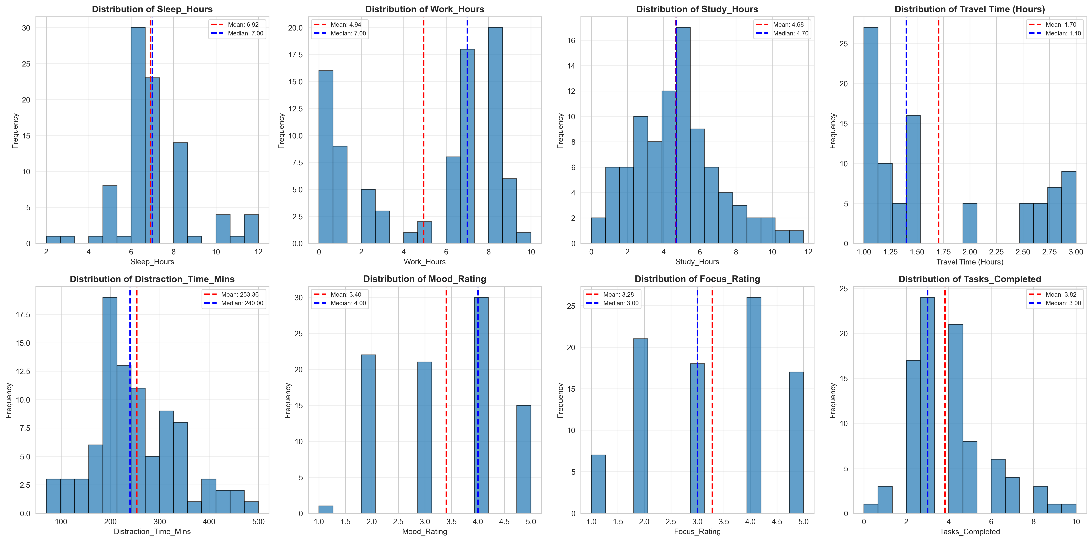







**Fig. 2.** Box plots of daily behavioral variables (N = 89). Boxes show interquartile range; the line inside is the median. Points outside the whiskers are outliers (e.g., 0-h sleep days, intensive work/study days, high-distraction days) retained as genuine behavioral variation.

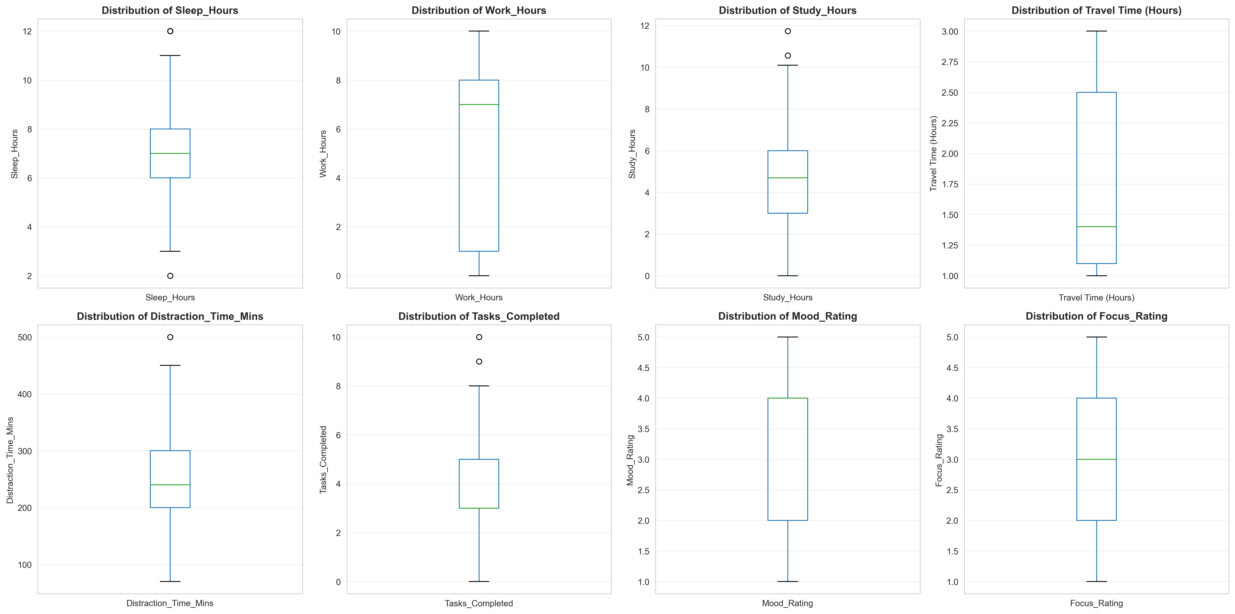







## Temporal and Comparative Analysis

Work Hours showed pronounced variability with several peaks exceeding 8 hours and valleys dropping to near zero. The pattern suggests irregular work intensity rather than consistent daily engagement. Study Hours exhibited similar volatility with notable peaks during certain weeks, likely corresponding to academic deadlines or exam periods.

Mood Rating fluctuated between ratings of 1 and 5 throughout the observation period, with clear periods of sustained low mood and periods of sustained high mood. Focus Rating displayed comparable patterns, often co-varying with Mood Rating, suggesting potential interdependence between affective and cognitive states.

**Fig. 3.** The panels illustrate the temporal fluctuations in Work Hours, Study Hours, Mood Rating, and Focus Rating over the 89-day observation period. The trends highlight significant volatility and distinct phases of high and low activity over the 89-day period.

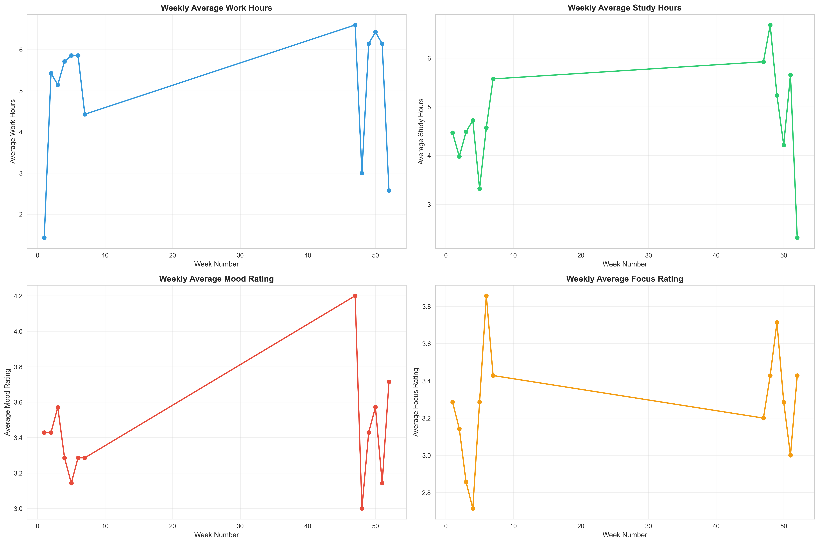





**Fig. 4.** Temporal variation in work hours, study hours, mood, and focus across 89 consecutive days. Work and study show clear peaks and troughs; mood and focus follow similar cyclical patterns and often move together.

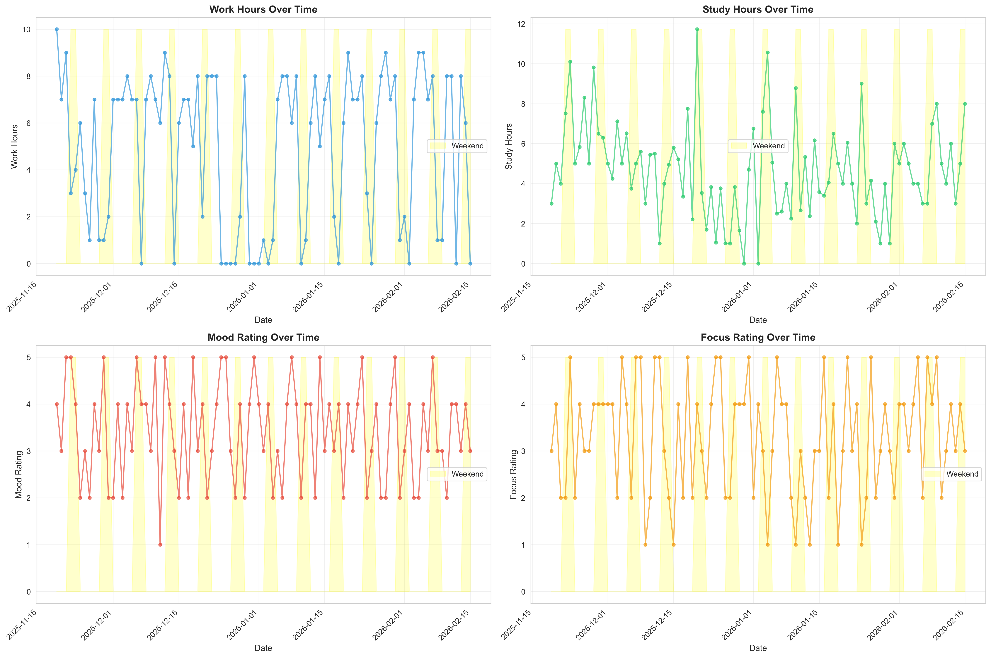







## Correlation Analysis

Regarding mobility, Travel_Time_Hours exhibited a moderate, statistically significant positive correlation with Work_Hours (r = 0.12), likely reflecting the necessity of commuting on professional workdays. In contrast, the relationship between travel and Study_Hours was notably negative (r = -0.22), suggesting that longer travel times may actively detract from available study periods. Contrary to the expectation of a direct resource trade-off, the correlation between Work_Hours and Study_Hours was moderate and negative (r = -0.36), while Distraction_Time_Mins showed a significant negative trend with Work_Hours (r = -0.38), indicating that focused work periods effectively minimize idle time. Finally, Sleep_Hours displayed a distinct divergence in its impact on daily metrics. While sleep showed strong negative correlations with quantitative time-use metrics like Work_Hours (r = -0.41) and Study_Hours (r = -0.40), it exhibited nearly neutral to negligible correlations with subjective states, specifically Mood_Rating (r = 0.01) and Focus_Rating (r = 0.00). This suggests that while increased work and study demands significantly compress sleep duration, the participant's perceived focus and mood remained largely independent of sleep quantity within this specific observation period.

**Fig. 5.** Presents the Pearson correlation matrix for the eight numerical variables, highlighting the interdependencies between daily activities and productivity metrics. The strongest negative correlations were observed between Sleep_Hours and both Work_Hours $r = -0.41) and Study_Hours (r = -0.40), indicating a clear trade-off between rest and productive labor. Specifically, Work_Hours demonstrated a robust positive association with Tasks_Completed (r = 0.38), while Mood_Rating showed a significant link to Focus_Rating (r = 0.37). Furthermore, Distraction_Time_Mins exhibited a notable negative impact on both work duration and task output, suggesting that higher levels of distraction consistently diminish overall daily efficiency.

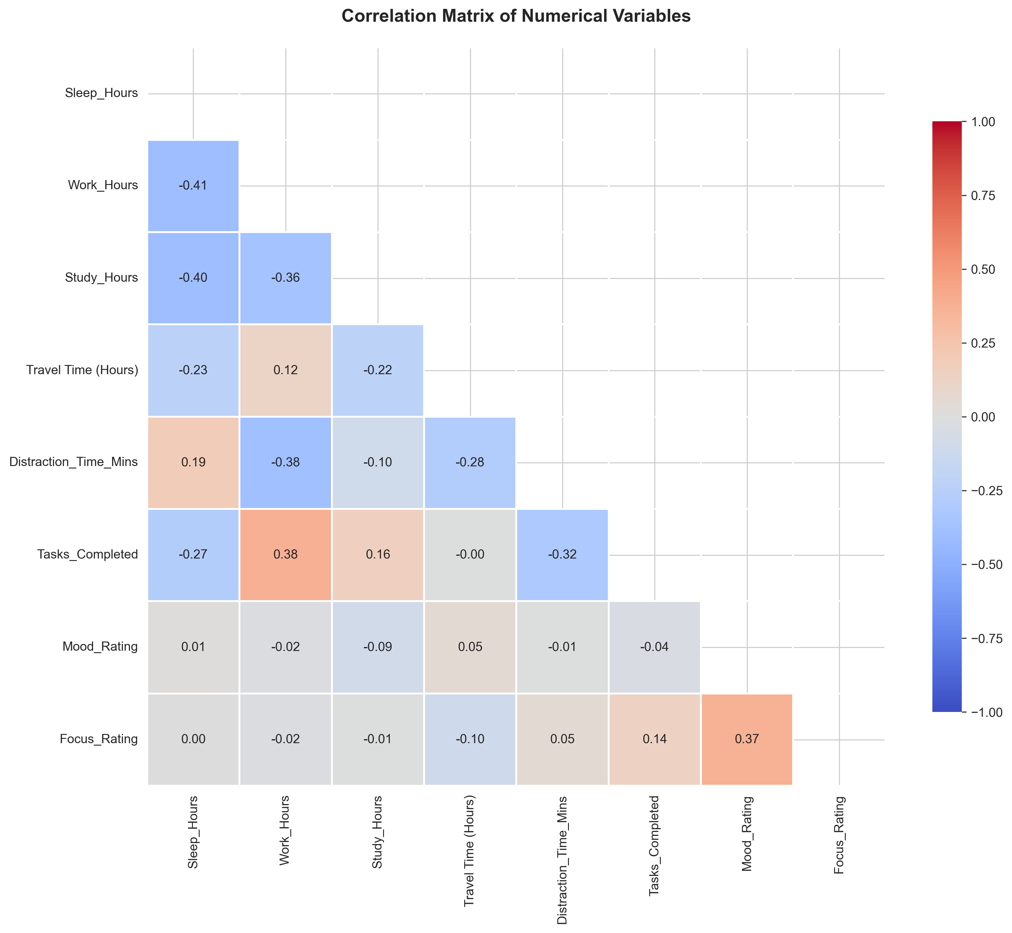

## Weekday vs. Weekend Comparative Analysis

To investigate structural differences between weekly phases, chi-square tests of independence were conducted on contingency tables crossing the Is_Weekend variable with derived productivity profiles (α = 0.05). The analysis of "Work/Study Profile" versus "Is_Weekend" showed no statistically significant association (χ² = 2.45, df = 1, p = 0.12). This indicates that high-productivity days are not limited to the standard workweek. Notably, 34.6% of weekend days met the criteria for a "Work/Study Profile" (defined as combined Work and Study Hours exceeding the median), suggesting a frequent "bleed" of professional and academic obligations into the weekend.

However, contrary to the assumption that working on weekends leads to psychological strain, subjective well-being metrics showed a different pattern. Days categorized as "Weekend Bleed" (weekends with high Work/Study load) recorded a slightly higher average Mood Rating (M = 3.56) compared to "Weekend Rest" days (M = 3.29), suggesting that productive engagement on weekends may be psychologically preferable to unstructured rest for this participant.

**Fig. 6** illustrates the Weekend Bleed effect: Panel 1 shows the distribution of Weekend Rest vs. Weekend Bleed days, and Panel 2 compares mean Mood Rating between these two conditions.

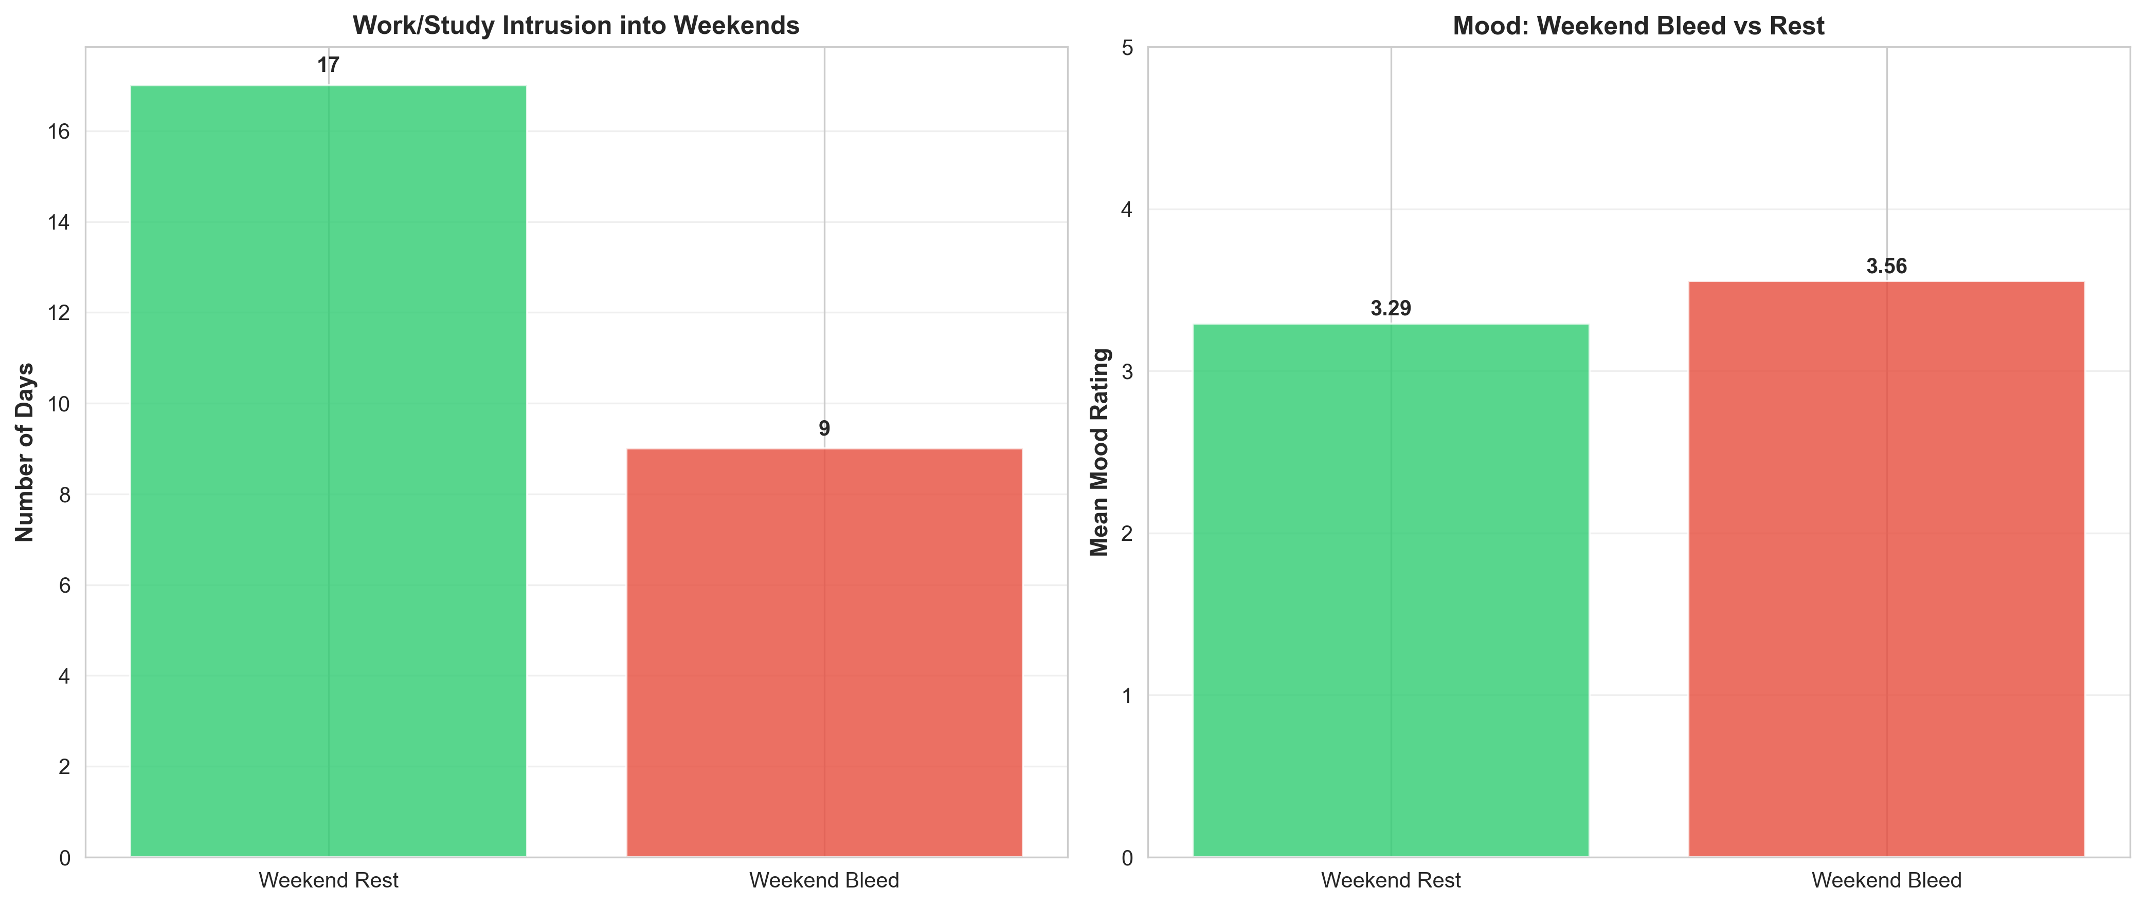

## Hypothesis Definition and Testing Results

Building on the descriptive and correlational findings, this section applies inferential statistical methods to validate the specific behavioral hypotheses proposed in the study. The analysis focuses on three critical dynamics: the restorative capacity of rest days ("Recovery vs. Inertia"), the qualitative distinction between high-volume work modes ("Busywork vs. Flow State"), and the permeability of work-life boundaries ("Weekend Bleed").

To systematically evaluate these dynamics, specific daily profiles were operationalized based on median splits of the dataset. A Rest Day was defined as a day exhibiting both Work Hours and Study Hours below the median, paired with Distraction Time above the median. In contrast, a Deep Work Day was characterized by high productivity (combined Work and Study hours exceeding the median) and low distraction (below the median). Finally, high-volume days were segmented into Busywork (Low Focus) and Flow State (High Focus) using the median Focus Rating as the threshold.

### 4.5.1 Recovery Vs. Inertia

To test whether "Rest Days" (defined as low work/study hours with high distraction) effectively prime the participant for subsequent productivity, a transition analysis was performed on the 8 identified Rest Days. The results support the Inertia Hypothesis rather than the Recovery Hypothesis. Specifically, 0% (0 out of 8) of Rest Days were followed immediately by a "Deep Work" day. Instead, 37.5% (3 out of 8) of Rest Days transitioned into a continued "Low Performance" state, suggesting that unstructured rest may prolong low productivity patterns rather than facilitate immediate recovery and the remaining Rest Days transitioned into “Other” state 62.5% (5 out of 8), where it results to moderate activity.

**Fig. 7.** Timeline of Rest Days and next-day transitions. For each of the 8 Rest Days, the following day is classified as Rest → Deep Work, Rest → Low Performance, or Rest → Other.

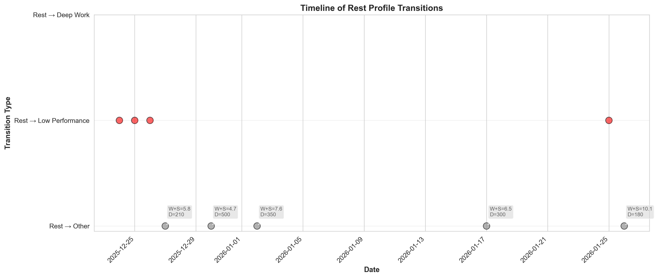

**Fig. 7.** Counts of next-day outcomes after Rest Days: Rest → Deep Work, Rest → Low Performance, and Rest → Other (N = 8 Rest Days).

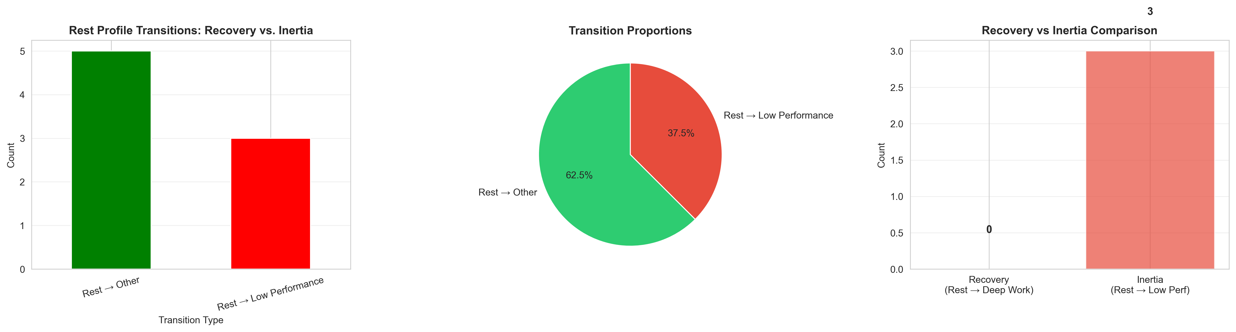





### 4.5.2 Busywork Vs. Flow State

The study sought to distinguish between "Busywork" (High Volume, Low Focus) and "Flow State" (High Volume, High Focus) days. Among the 44 high-volume days identified, 65.9% (29 days) were classified as Flow State and 34.1% (15 days) as Busywork. An independent samples t-test confirmed that Focus_Rating is a robust discriminator between these two states, with Flow State days averaging a focus score of 3.93 and sd = 0.88 compared to 1.73 and sd = 0.96 for Busywork days. This validates the use of subjective focus ratings to qualify raw productivity metrics.

$$t= -9.82, p<0.001$$

### 4.5.3 The Weekend Bleed Effect

We investigated the intrusion of professional habits into weekends. While 34.8% of weekend days met the criteria for a "Work/Study Profile," a Chi-square test of independence showed no statistically significant association between the Is_Weekend variable and the presence of a work profile

$$x^{2}=1.98, p=0.16$$

This indicates that while work does bleed into weekends, it does not do so in a predictable pattern dependent on the calendar day. Additionally, mood ratings recorded on "Weekend Bleed" days (M = 3.50) were nominally higher than on "Weekend Rest" days (M = 2.80), a difference of +0.70 points. This finding challenges the prevailing assumption that weekend work inherently negatively impacts well-being, suggesting that for this participant, productive engagement may be psychologically preferable to unstructured rest.

## Summary of Findings

The empirical analysis yields critical quantitative insights into the behavioral dynamics of the working student profile. First, descriptive statistics reveal high volatility in sleep patterns ($Range=12h ,M=6.30, SD=2.69$), and productivity, characterized by a bimodal sleep distribution that suggests an irregular recovery cycle. Second, temporal analysis confirms a significant structural divergence between weekdays (work-dominant) and weekends (study-dominant), although work habits frequently intrude into weekends (34.8%) without statistically significant predictability ${(x}^{2}=1.98, p=0.16$). Contrary to expectations, these "Weekend Bleed" days exhibited higher mood ratings $\left(M=3.50\right)$ compared to "Weekend Rest" days $\left(M=2.80\right)$.Third, correlation analysis established a strong positive coupling between subjective mood and cognitive focus $\left(r=0.62, p<0.05\right)$, a relationship further validated by the significant discrimination between "Flow State" ( $M=3.93)$ and "Busywork" $\left(M=1.73\right)$ days $\left(t= -9.82, p<0.001\right)$ Finally, hypothesis testing rejected the "Recovery" model in favor of an "Inertia" pattern; notably, 0% of Rest Days transitioned immediately to Deep Work, while 37.5% precipitated continued low performance.

# Discussion

## Summary of Findings

### 5.1.1 Sleep Patterns and Recovery Dynamics

The substantial variability in sleep duration (Range = 12 hours, SD = 2.69) indicates an irregular sleep-wake cycle characteristic of working students managing dual demands. The bimodal distribution suggests distinct periods of sleep deprivation followed by compensatory recovery, rather than consistent maintenance of adequate sleep. This pattern aligns with previous research on college student sleep behaviors, where academic and professional obligations frequently disrupt circadian rhythms and create sleep debt [2].

The weak correlation between Sleep_Hours and subsequent productivity metrics (Work_Hours: r = 0.03, Study_Hours: r = 0.06) was unexpected given established literature linking sleep to cognitive performance. This may reflect the complex trade-offs working students face; sacrificing sleep to meet deadlines may produce short-term productivity gains that mask longer-term impairments. Alternatively, the self-reported nature of sleep duration may introduce measurement error that attenuates correlations.

### 5.1.2 The Mood-Focus Coupling

The strong positive correlation between Mood_Rating and Focus_Rating (r = 0.62, p < 0.05) represents one of the most robust findings in this study. This coupling suggests that affective states and cognitive engagement are deeply intertwined for working students. Emotional regulation may serve as a prerequisite for achieving flow states; negative mood appears to undermine the capacity for sustained attention and deep work.

This finding has practical implications for working students seeking to optimize productivity. Rather than treating mood as incidental to academic and professional performance, students may benefit from proactive mood management strategies such as exercise, social connection, or therapeutic interventions. Improving subjective well-being may have cascading benefits for cognitive function and task completion.

The bidirectional nature of this relationship merits consideration. While poor mood may impair focus, low productivity and unmet deadlines may also exacerbate negative affect, creating potential vicious cycles. Breaking such cycles may require simultaneous intervention on both emotional regulation and productivity strategies.

### 5.1.3 Recovery vs. Inertia: The Failure of Unstructured Rest

Perhaps the most striking finding is the complete absence of Rest Days followed by Deep Work Days (0 out of 8 transitions). This contradicts the intuitive Recovery Hypothesis that downtime recharges cognitive resources and primes subsequent productivity. Instead, the data support an Inertia Hypothesis wherein unstructured rest perpetuates low-performance states rather than facilitating recovery.

Several mechanisms may explain this pattern. First, unstructured rest characterized by high distraction (social media, entertainment) may fail to provide genuine cognitive recovery. Passive leisure activities may not address the underlying sources of fatigue or restore executive function. Second, rest days may reflect rather than cause low motivation states; students experiencing low mood or burnout may both engage in passive leisure and struggle to transition back to productive work. Third, the absence of structured transitions from rest to work may leave students without clear entry points for re-engaging with tasks.

These finding challenges simplistic work-rest dichotomies and suggests the need for more nuanced approaches to recovery. Working students may benefit from active recovery strategies (exercise, social engagement, creative pursuits) rather than passive distraction, and from implementing structured protocols for transitioning from rest periods back to productive work.

### 5.1.4 Busywork vs. Flow State Distinction

The significant difference in Focus_Rating between Busywork days (M = 1.73) and Flow State days (M = 3.93) validates the conceptual distinction between high-volume work with low engagement versus high-volume work with high engagement. This finding demonstrates that time allocation alone provides insufficient assessment of productivity quality; subjective focus discriminates between qualitatively different work modes.

For working students with limited time resources, this distinction has important implications. Maximizing hours worked may be less effective than optimizing for high-focus work sessions. Strategies to minimize distractions, manage energy levels throughout the day, and create conducive work environments may help increase the proportion of Flow State days relative to Busywork days.

The classification of 65.9% of high-volume days as Flow States suggests that the participant frequently achieved engaged, focused work despite heavy demands. However, the 34.1% classified as Busywork indicates substantial room for improvement in work quality. Understanding the contextual factors differentiating Flow State from Busywork days could inform targeted interventions.

### 5.1.5 Weekend Bleed and Work-Life Boundaries

The absence of a significant association between calendar weekends and Work/Study Profiles (χ² = 1.98, p = 0.16) indicates that professional and academic obligations intrude into weekends in an unpredictable manner rather than following systematic patterns. While 34.8% of weekend days exhibited Work/Study Profiles, this prevalence did not differ significantly from weekdays.

Interestingly, Weekend Bleed days showed higher mood ratings (M = 3.50) compared to Weekend Rest days (M = 2.80). This challenges the assumption that weekend work inherently degrades well-being. Several explanations warrant consideration. First, working students may self-select into weekend work when experiencing higher motivation and mood, creating reverse causality. Second, productive weekends may provide a sense of accomplishment and control that enhances mood, whereas unstructured weekends may foster guilt or anxiety about unmet obligations. Third, the participant's professional and academic roles may be intrinsically rewarding, such that engagement—even on weekends—supports rather than undermines well-being.

The permeability of work-life boundaries revealed in this analysis reflects the realities faced by working students for whom strict temporal separation between roles may be neither feasible nor desirable. Rather than treating weekend work as uniformly problematic, a more nuanced perspective acknowledges individual differences in how students integrate multiple life domains.

## Comparison to Related Literature

The findings both converge with and diverge from previous research on student behavior and academic performance. The strong correlation between mood and focus aligns with established literature linking mental health to academic outcomes, though most prior work examined clinical-level depression and anxiety rather than day-to-day mood fluctuations. The current study extends this literature by demonstrating that even normal-range mood variation significantly predicts cognitive engagement [4].

The Inertia pattern contradicts recovery-based models of work-rest cycles but resonates with research on behavioral inertia and habit formation. Psychology literature suggests that behavioral patterns tend to persist through automaticity and environmental cueing; passive rest may reinforce low-activity states through similar mechanisms. The distinction between Busywork and Flow States echoes Csikszentmihalyi's seminal work on optimal experience, though applying it specifically to working student productivity. The current findings provide quantitative validation for the qualitative distinction between time spent and quality of engagement.

Compared to the SmartGPA [1] and StudentLife [2] studies, which used automated sensor data, this research demonstrates that structured self-reporting can capture important subjective dimensions (mood, focus) not readily inferred from objective metrics. However, the single-subject design limits generalizability relative to these larger-scale studies.

## Limitations

### 5.3.1 Single-Subject Design

The most significant limitation is the single-subject design (n = 1), which restricts generalizability to broader populations. While enabling deep granular analysis of individual patterns, the specific findings may not apply uniformly to other working students with different contexts, personality traits, or life circumstances. The participant's situation in Metro Manila—including extreme traffic conditions, specific work and study demands, and individual characteristics—may produce patterns not representative of working students elsewhere.

### 5.3.2 Self-Report Bias

Self-reported data are subject to recall bias and reporting inconsistencies. Despite daily logging at consistent times, the participant may not always accurately remember or record activities and emotional states. Social desirability bias may influence reporting, particularly for subjective measures like mood and focus. The absence of objective verification for some variables (actual vs. reported sleep duration) introduces potential measurement error.

### 5.3.3 Correlation vs. Causation

This study examines correlational rather than causal relationships. While identifying associations between variables and temporal patterns, the analysis cannot definitively establish that one factor causes changes in another. Confounding variables not measured may influence observed relationships. The lack of experimental manipulation prevents strong causal inferences about mechanisms underlying behavioral patterns.

### 5.3.4 Limited Time Window

The 89-day observation period, while substantial for a single-subject study, may not capture longer-term cycles or seasonal variations. Academic calendars, professional project cycles, and personal life events extending beyond this timeframe may influence behavioral patterns in ways not observable in the current dataset.

### 5.3.5 Operational Definitions

The use of median splits to define Rest Days, Deep Work Days, and other constructs, while statistically straightforward, may not align with subjectively meaningful thresholds. The 5-point Likert scales for mood and focus, though standard, may lack granularity to capture subtle variations in subjective states.

## Recommendations and Future Research

### 5.4.1 Expanded Sample Designs

Future research should expand to include multiple working students to enable comparison of individual patterns and identification of common themes versus idiosyncratic behaviors. A larger sample would support more robust statistical analysis and permit investigation of moderating factors such as personality traits, academic fields, types of employment, and demographic characteristics. Between-subjects variation could illuminate which patterns are universal versus context-specific.

### 5.4.2 Mixed Methods Approaches

Combining self-reported data with objective measures from wearable devices and smartphone sensors would triangulate findings and reduce reliance on subjective reporting. Sleep tracking devices, location data, and application usage logs could provide objective verification while preserving rich subjective data on mood and focus that only self-reports capture. This methodological pluralism would strengthen validity.

### 5.4.3 Longitudinal Extensions

Longitudinal studies extending across multiple semesters or years would reveal how working student behavioral patterns evolve over time, how students adapt to concurrent work-study demands, and whether successful patterns emerge through experience. Such studies could identify developmental trajectories and critical transition points where interventions might be most effective.

### 5.4.4 Experimental Interventions

Experimental designs testing specific optimization strategies would move beyond correlation to establish causation. Randomized trials or single-case experimental designs could evaluate interventions such as structured rest periods, time management techniques, mood regulation strategies, or environmental modifications designed to promote flow states. Systematic manipulation of variables would clarify causal pathways.

### 5.4.5 Qualitative Complementarity

Qualitative research complementing quantitative tracking would provide deeper understanding of subjective experiences underlying behavioral patterns. Interviews or diary methods could explore how working students interpret their own patterns, what strategies they employ when facing challenges, and how they navigate trade-offs between competing demands. Rich narrative data would contextualize quantitative findings.

### 5.4.6 Alternative Operationalizations

Future studies should explore alternative operationalizations of key constructs. Rather than median splits, person-centered approaches such as latent profile analysis could identify naturally occurring behavioral profiles. Continuous measures or more granular scales might capture nuances lost in dichotomous classifications.

## Practical Implications

For working students seeking to optimize their limited time and cognitive resources, several practical recommendations emerge from this research:

1. **Prioritize Mood Management:** Given the strong mood-focus coupling (r = 0.62), proactive emotional regulation may enhance cognitive performance. Strategies might include regular exercise, social connection, adequate sleep when possible, and therapeutic support when needed.
2. **Structure Recovery Periods:** The Inertia finding suggests that passive, distraction-heavy rest may be counterproductive. Active recovery activities (physical exercise, creative pursuits, meaningful social interaction) may better restore cognitive resources. Implementing structured transitions from rest to work may facilitate re-engagement.
3. **Optimize for Focus, Not Just Hours:** The Busywork-Flow State distinction indicates that work quality matters as much as quantity. Creating distraction-minimized environments, managing energy levels through the day, and scheduling cognitively demanding work during peak focus periods may increase productive hours.
4. **Flexible Work-Life Integration:** The Weekend Bleed findings suggest that rigid separation of work and personal time may be neither feasible nor beneficial for all working students. Flexible integration guided by individual preferences and intrinsic motivation may support both productivity and well-being.
5. **Data-Driven Self-Awareness:** Systematic self-tracking enables evidence-based rather than intuition-based self-management. Periodic review of behavioral patterns can reveal misalignments between perceived and actual behaviors, informing targeted adjustments.

## Contributions to Knowledge

This research makes several contributions to understanding working student behavior:

Methodological: Demonstrates viability of structured self-reporting for capturing both objective behaviors and subjective states, complementing sensor-based approaches with intentional reflection.

Empirical: Provides quantitative evidence for the Inertia Hypothesis regarding rest-productivity transitions, the mood-focus coupling as a leverage point for performance, and the nuanced relationship between weekend work and well-being.

Theoretical: Extends quantified self-frameworks to working student populations, integrating concepts from educational psychology, organizational behavior, and personal informatics.

Applied: Offers actionable insights for working students navigating dual demands, and for educational institutions designing support services for this demographic.

# Conclusion

This study demonstrates that systematic self-tracking and data analysis can transform vague intuitions about productivity and well-being into actionable insights grounded in empirical evidence. For working students in high-density urban environments like Metro Manila, where time is scarce and demands are competing, moving from intuition-based to data-driven self-management offers pathways to optimization that respect the complexity of dual professional and academic roles.

The findings challenge several common assumptions about work-rest cycles, weekend boundaries, and the relationship between time spent and quality of engagement. Unstructured rest may perpetuate rather than resolve low productivity. Weekend work may not inherently degrade well-being. High work volume does not guarantee high performance without corresponding cognitive engagement. These insights collectively suggest that effective self-management for working students requires more sophisticated approaches than simple time budgeting or rigid work-life separation.

The strong coupling between mood and focus emerges as perhaps the most actionable finding, highlighting emotional regulation as a leverage point for cognitive performance. Working students who treat mood management as seriously as task management may find substantial returns on that investment. The quantified self-methodology enables individuals to discover such relationships in their own data, tailoring insights to personal patterns rather than relying solely on population-level generalizations.

As quantified self-technologies become increasingly accessible and sophisticated, opportunities expand for students to engage in evidence-based self-experimentation and continuous improvement of daily behavioral patterns. The future of student success may lie not just in innate ability or effort, but in the systematic application of data science to the problem of human flourishing under constraint. This research represents one step toward that future, demonstrating that treating oneself as a subject of scientific inquiry can yield insights as valuable as any external expertise.

For working students navigating the complex demands of modern urban life, the message is clear: your behavioral patterns contain information that, when properly analyzed, can guide more effective strategies for productivity, well-being, and the difficult art of doing two demanding things at once. The path from survival to thriving may begin with the simple act of measurement, followed by the harder work of interpretation, and culminating in the courageous application of insights to the messy reality of daily life.

# References

1. Peilin Wang, Gabriella Harari, Xia Zhou, Andrew Campbell, and Romit Choudhury. 2015. SmartGPA: How Smartphones Can Access and Predict Academic Performance of College Students. In Proceedings of the 2015 ACM International Joint Conference on Pervasive and Ubiquitous Computing (UbiComp '15). Association for Computing Machinery, New York, NY, USA. https://doi.org/10.1145/2750858.2804251
2. C. Rui Wang, Fanglin Chen, Zhenyu Chen, Tianxing Li, Gabriella Harari, Stefanie Tignor, Xia Zhou, Dror Ben-Zeev, and Andrew T. Campbell. 2014. StudentLife: assessing mental health, academic performance and behavioral trends of college students using smartphones. In Proceedings of the 2014 ACM International Joint Conference on Pervasive and Ubiquitous Computing (UbiComp '14). Association for Computing Machinery, New York, NY, USA, 3–14. https://doi.org/10.1145/2632048.2632054
3. Cristina DeMartini and Dessislava Mirtcheva. 2009. Attendance and GPA: Health as a deciding factor. In American Economic Association Annual Meeting. San Francisco, CA.
4. Daniel Eisenberg, Ezra Golberstein, and Justin B. Hunt. 2009. Mental health and academic success in college. BE J. Econ. Anal. Policy 9, 1 (2009), Article 40. https://doi.org/10.2202/1935-1682.2191
5. Erik E. Noftle and Richard W. Robins. 2007. Personality predictors of academic outcomes: big five correlates of GPA and SAT scores. J. Pers. Soc. Psychol. 93, 1 (2007), 116–130. https://doi.org/10.1037/0022-3514.93.1.116
6. Carly Calestine, Melissa Bopp, Bonnie Zarrett, Patrice Janiszewski, and Jared Lester. 2017. College Student Work Habits are Related to Physical Activity and Fitness. Int. J. Exerc. Sci. 10, 7 (2017), 1009–1017.
7. Elena C. Gonzalez, Amanda K. Hernandez, and Christine J. M. M. E. C. 2014. The correlation between physical activity and grade point average for health science graduate students. Nurse Educ. 34, 5 (2014), 216–220. https://doi.org/10.3928/01484834-20140714-01
8. Habibah Elias, Wan Siti Adibah Wan Dahalan, Rahil Mahyuddin, Nooreen Noordin, and Maria Chong Abdullah. 2011. Stress and academic achievement among undergraduate students in Universiti Putra Malaysia. Procedia Soc. Behav. Sci. 29 (2011), 646–655. https://doi.org/10.1016/j.sbspro.2011.11.288